**3D Printing**

Video 1 ABC’s of XYZ’s <https://vimeo.com/87086000>

Video 2 Materials and Processes <https://vimeo.com/87085999>

Video 3 Applications <https://vimeo.com/87086001>

**ABC’s of Printing XYZ’s**

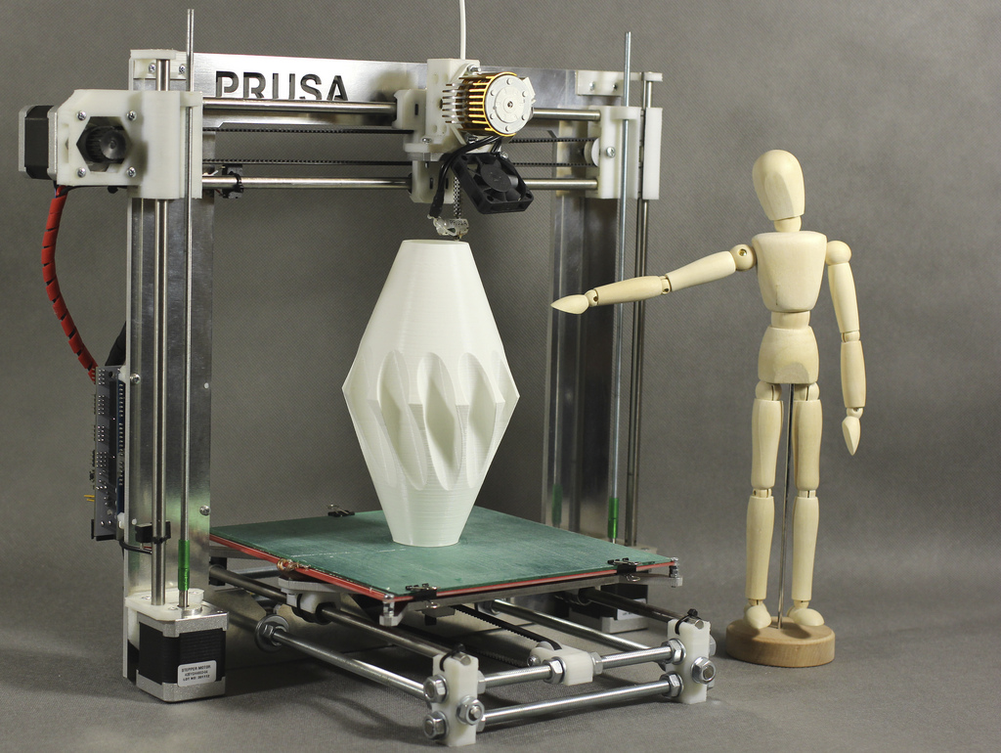

* Video: 3D Systems Cube <http://www.youtube.com/watch?v=uNyju-C7aIg>
  + X, Y, Z axis
  + Heated plastic sprayed in layers
  + The particles (3D dots) are around 50 to 100 µm (510 to 250 DPI) in diameter
  + Layer thickness and X-Y resolution typically around 100 [µm](http://en.wikipedia.org/wiki/Dots_per_inch) (250 [DPI](http://en.wikipedia.org/wiki/Dots_per_inch))
  + Print jobs can take from a couple hours to days
* Video RepRap (*Replicating Rapid Prototyper*) <http://www.youtube.com/watch?v=NX46AXfkbso>
  + Hollow core supportive structures
  + These types of printers can’t print stalactites without some sort of supportive structure

**What can be printed?**

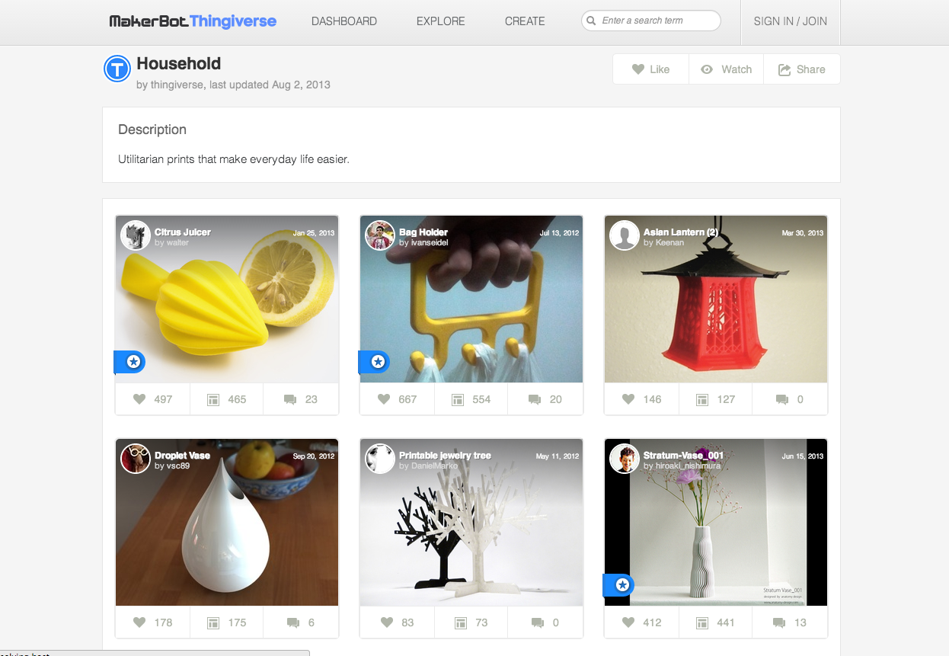

* STereoLithography (STL) files accessed from:
* Catalogues
  + Video: Cube <http://www.youtube.com/watch?v=Osu5MC2PtMI>
  + Makerbot Thingaverse: <http://www.thingiverse.com/>
  + Creative Commons License is often used
* 3D scanner
  + Handheld scanners
    - <http://www.youtube.com/watch?v=SyzgBycPxyw>
  + Fixed scanners
    - <http://www.youtube.com/watch?v=Qn5e2Zz2EEM>
    - <http://www.youtube.com/watch?v=AYq5n7jwe40>
* 3d modeling software or CAD software
  + Video: <http://www.youtube.com/watch?v=zuwVujIO_Pg>
  + Blender is free
  + Sketchup is user-friendly
  + Rhino and Autodesk are industrial strength

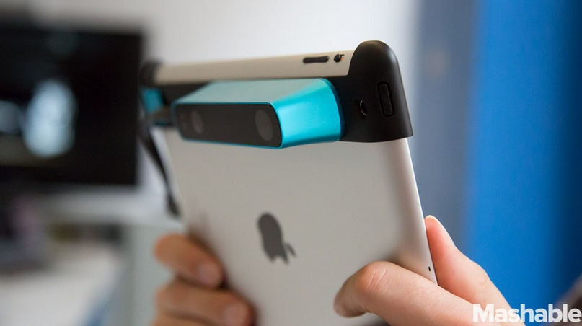

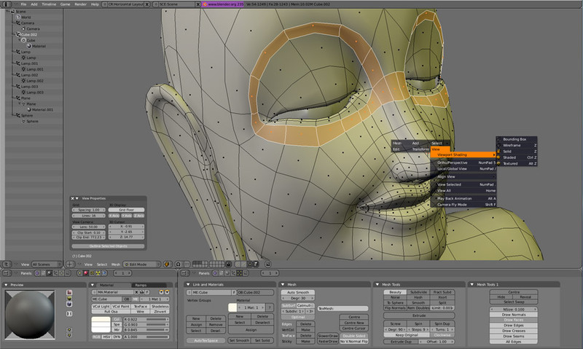

**3D Printing Materials**

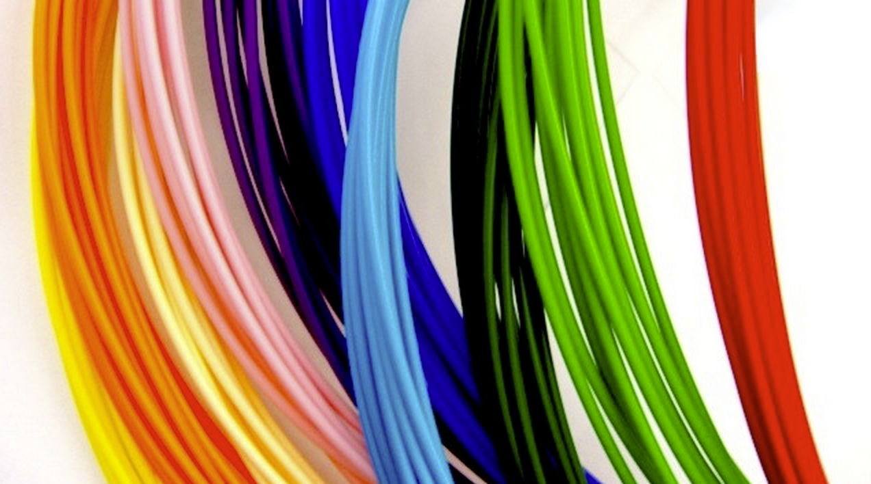

* Thermoplastic
  + Video: MakerBot Replicator uses two colors <http://www.youtube.com/watch?v=GpEmeM5LlHI>
  + ABS (Acrylonitrile butadiene styrene thermoplastic, softer more flexible - good for support structures)
  + PLA ([Polylactic acid](http://en.wikipedia.org/wiki/Polylactic_acid) bio-plastic, biodegradable, ridgid, more sturdy - good for flat objects)
* Rubber
* Clay
* Ceramic powder
* Concrete
* Metal alloys
* Titanium alloys
* Metal powders
* Paper
* Wood

**Industrial 3D Printing (Additive) Processes**

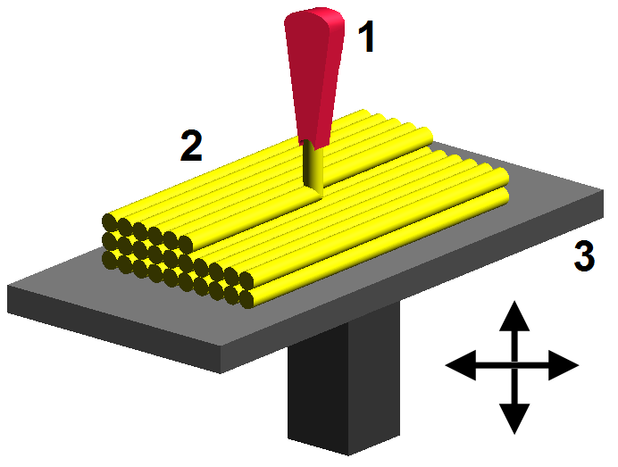

* Extrusion Deposition
  + Fused deposition modeling (FDM)
  + Model is produced by extruding small beads of material which harden immediately to form layers
  + What we’ve been viewing
  + Video Polyjet <http://www.youtube.com/watch?v=D4Yq3glEyec>
    - cured with UV light
    - platform lowers 1/1000th of an inch
    - build agent and support agent
    - multiple materials can be fused together
    - moving parts made possible because of support agent

### 

### Granular materials binding

* + Model is produced through selective fusing of materials in a granular bed
  + Selective Laser Sintering (SLS) <http://www.youtube.com/watch?v=9E5MfBAV_tA>
  + Selective Laser Melting (SLM) <http://www.youtube.com/watch?v=KFlG-KPOvyQ>
  + Electron beam melting (EBM) <http://www.youtube.com/watch?v=E7--ZWPVVdQ> (medical implants)

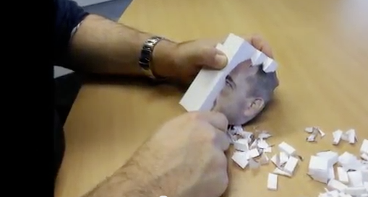

* Lamination:
  + typically paper (Mcor) - now in color!
  + <http://www.youtube.com/watch?v=GVzRyKxD6Zc>,
  + <http://www.youtube.com/watch?v=bnn-ACoMw4w>

### 

### Photopolymerization

* + Stereolithography (SLA) - produce a solid part from a liquid polymer using UV light
  + [Digital Light Processing](http://en.wikipedia.org/wiki/Digital_Light_Processing) (DLP) <http://www.youtube.com/watch?v=IDHgWnUqLRU&feature=share&list=PLFleSSoqTJkh-Ni9MD9HNsi0EZrADEmP9>
  + Peachy Printer <https://www.kickstarter.com/projects/117421627/the-peachy-printer-the-first-100-3d-printer-and-sc>

**3D Printing Applications**

#### **Rapid prototyping, rapid manufacturing, mass customization, mass production** <http://www.youtube.com/watch?v=GDLas_2Qy-E>

* Art, ceramics, <http://www.youtube.com/watch?v=r0TQKm5ciY0>, <http://www.youtube.com/watch?v=zQxa920YGaU>
* Building materials <http://www.youtube.com/watch?v=EfbhdZKPHro>
* Buildings <http://www.youtube.com/watch?v=-yv-IWdSdns>
* Organs <http://www.youtube.com/watch?v=7SfRgg9botI>
* Meat and leather <http://www.youtube.com/watch?v=BYzt6vAj_Xg>
* Food <http://www.youtube.com/watch?v=x6WzyUgbT5A>, <http://www.youtube.com/watch?v=BIFi8but3Vw>
* Fashion <http://www.youtube.com/watch?v=OFecNIntJuo>

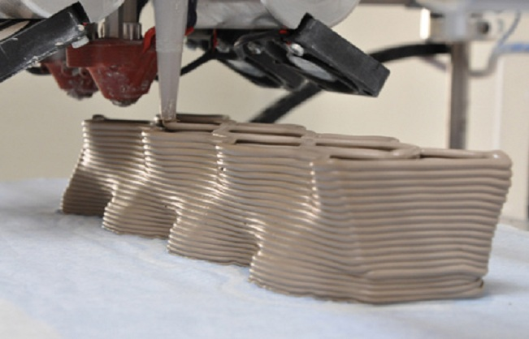

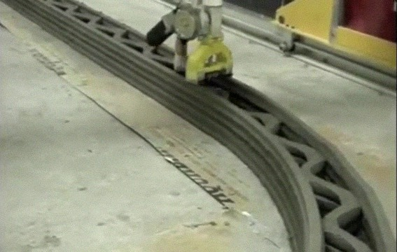



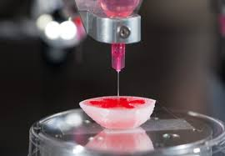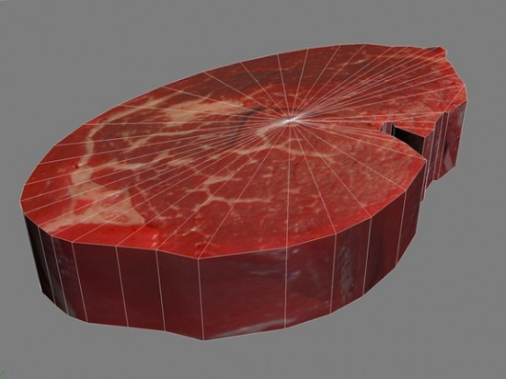

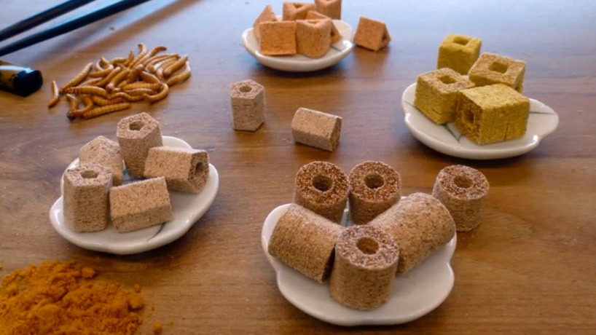

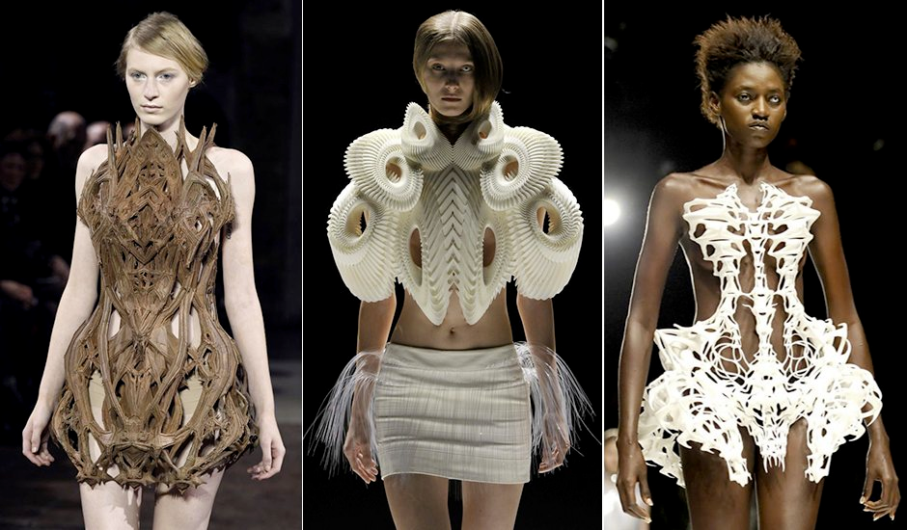

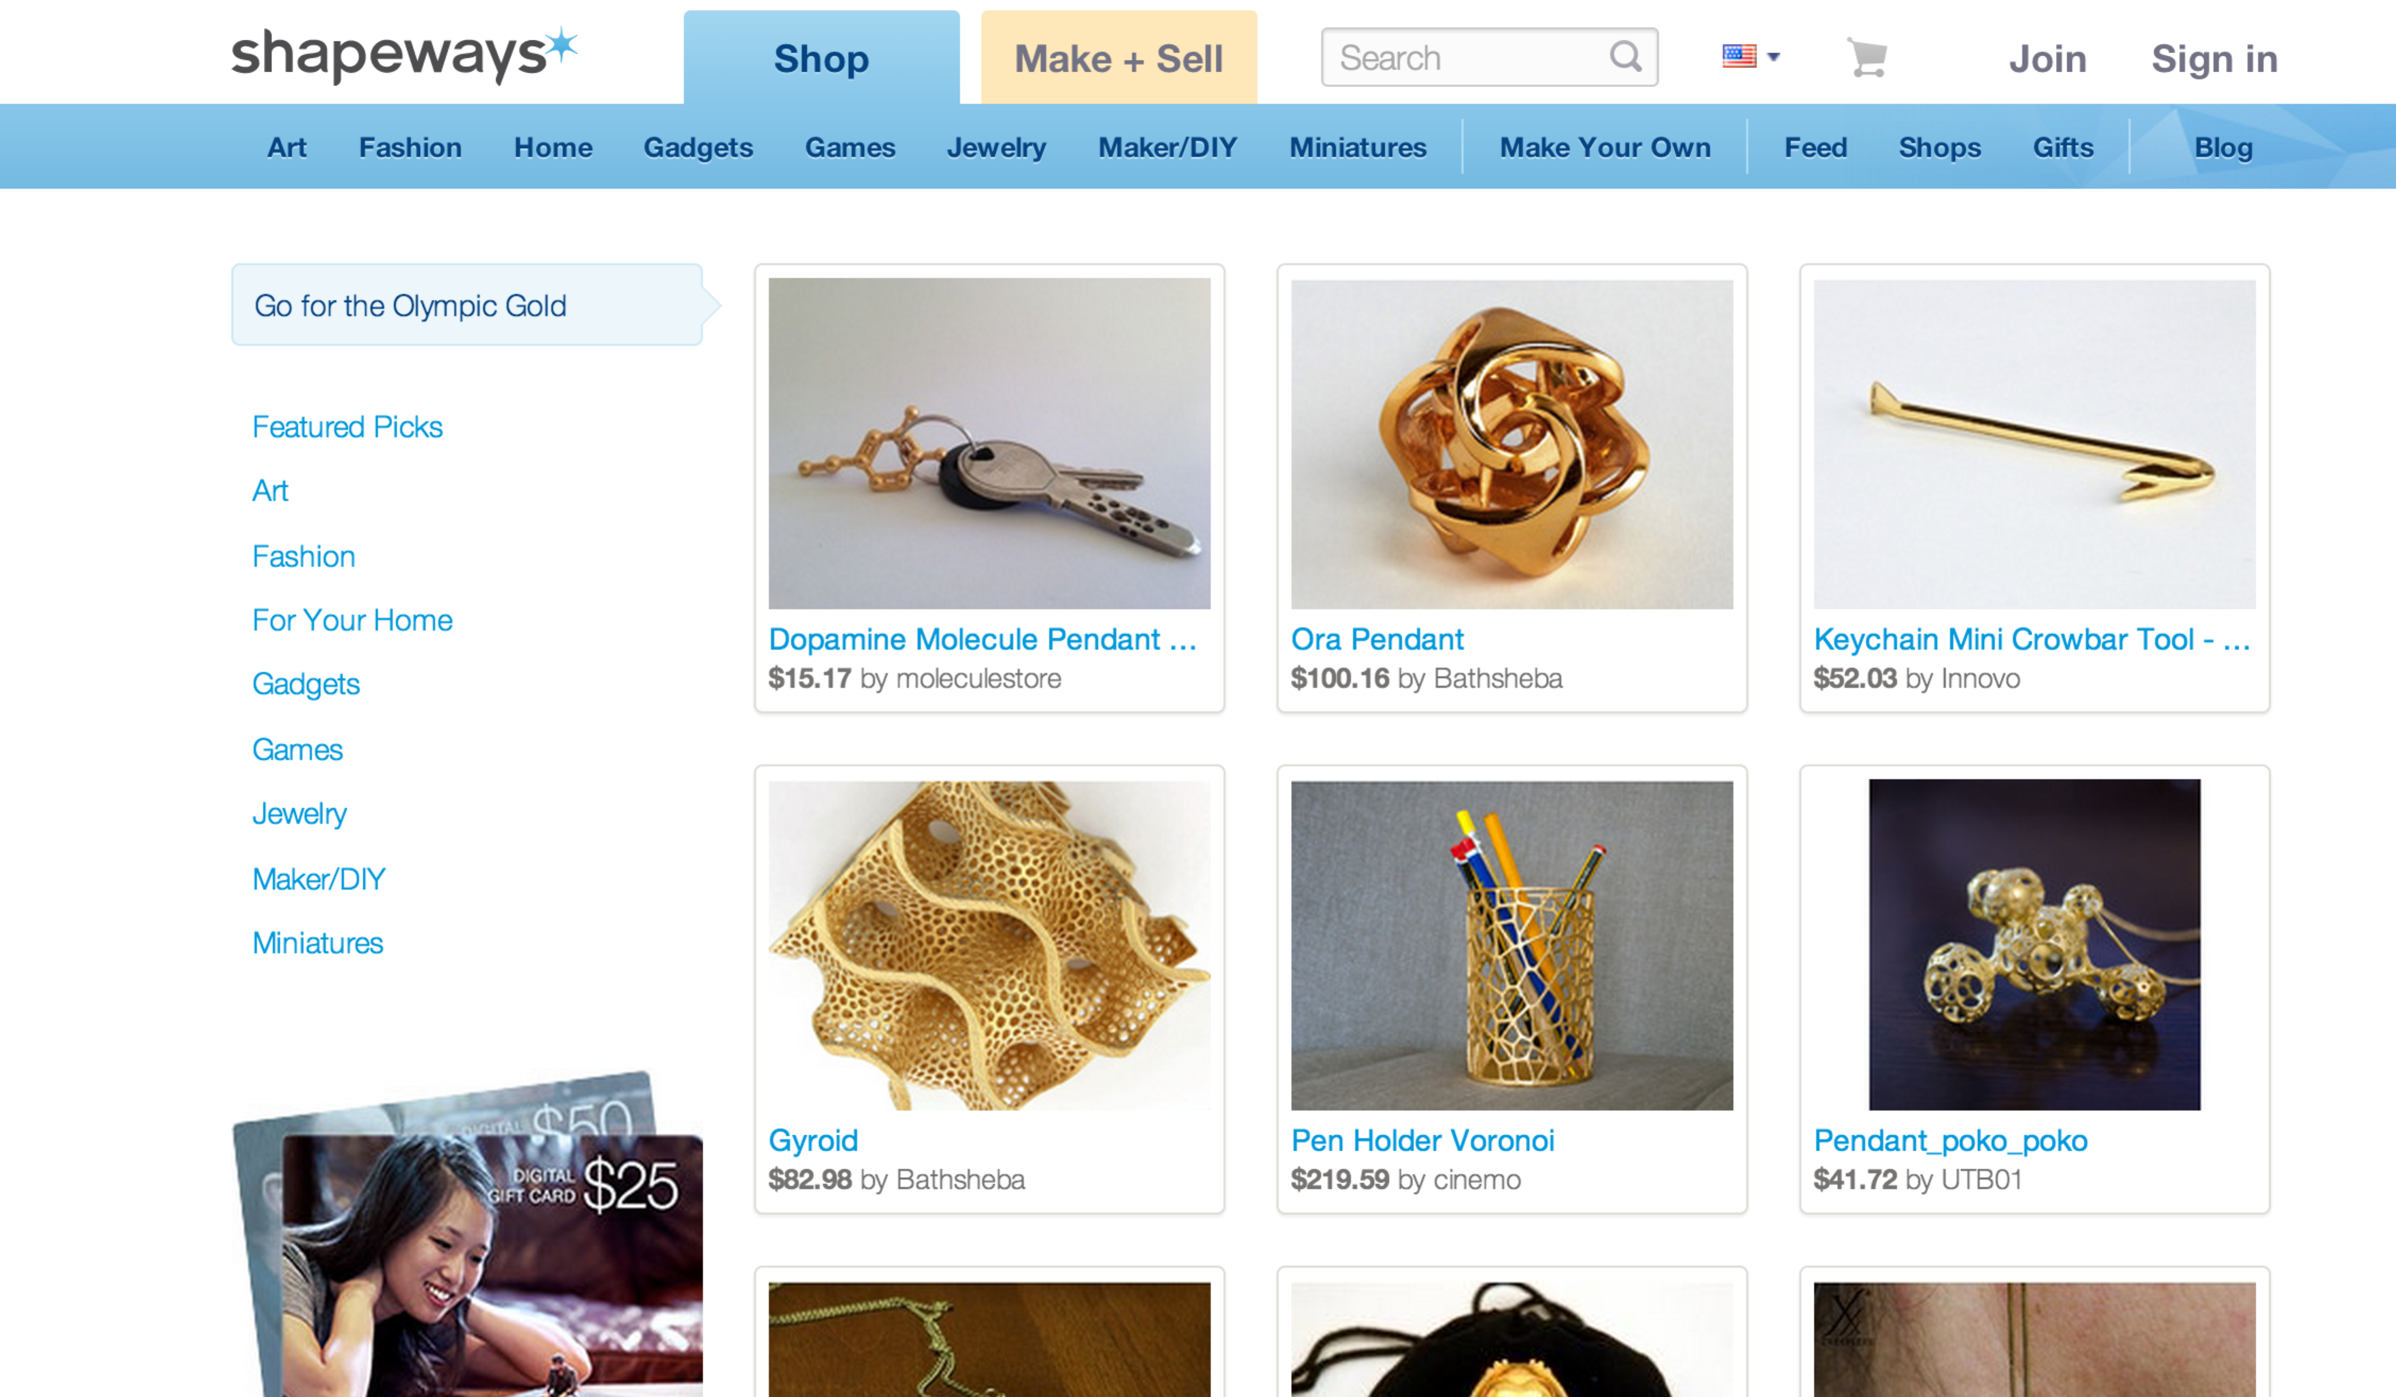 Buy your own printer or use a service?

* [www.shapeways.com](http://www.shapeways.com)